**FILE LINK**

There are two types of links:

1. Soft Links

2. Hard Links

**1. Soft Links:**

➢ A soft link also known as a symbolic link (or) symlink in

Linux is a type of file that acts as a pointer or reference to

another file or directory.

➢ We can also say it as hanging link.

For Example,

It is like a shortcut in windows which contains the path

of the original file and not the contents

**Command for soft linking a file or directory**

**---------------------------------------------------------**

**ln -s (sourcefile) (destinationfile)**

**ln -s (sourcefile full path) (destinationfile full path)**

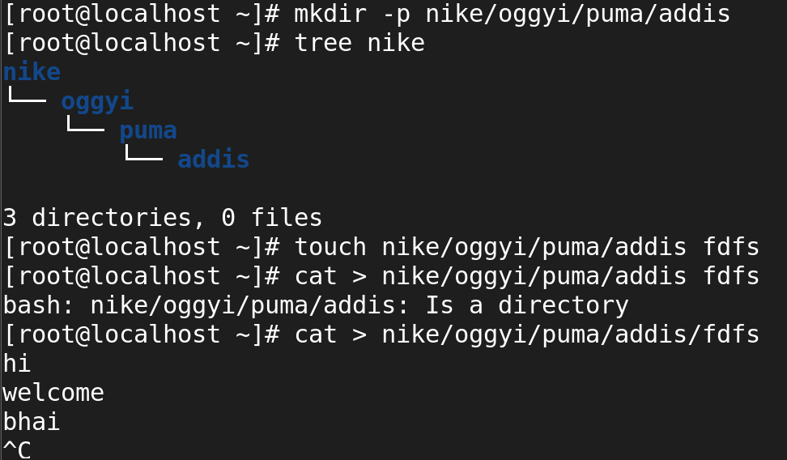

I created file link for addias -as -shoes (dir) file(fdfs)

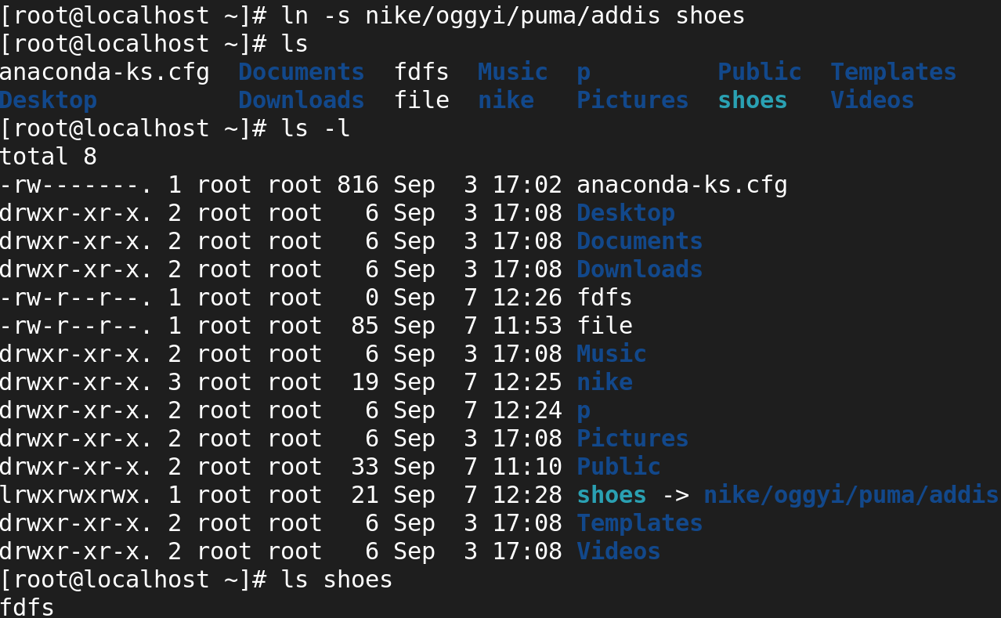gg

For the soft link the io number will be differ for main dir (nike) and duplicate link dir( shoes).

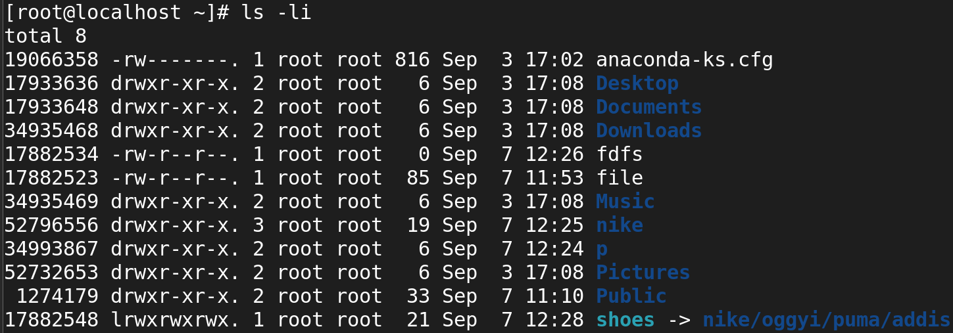

Removeing oggiy dir from the nike path.

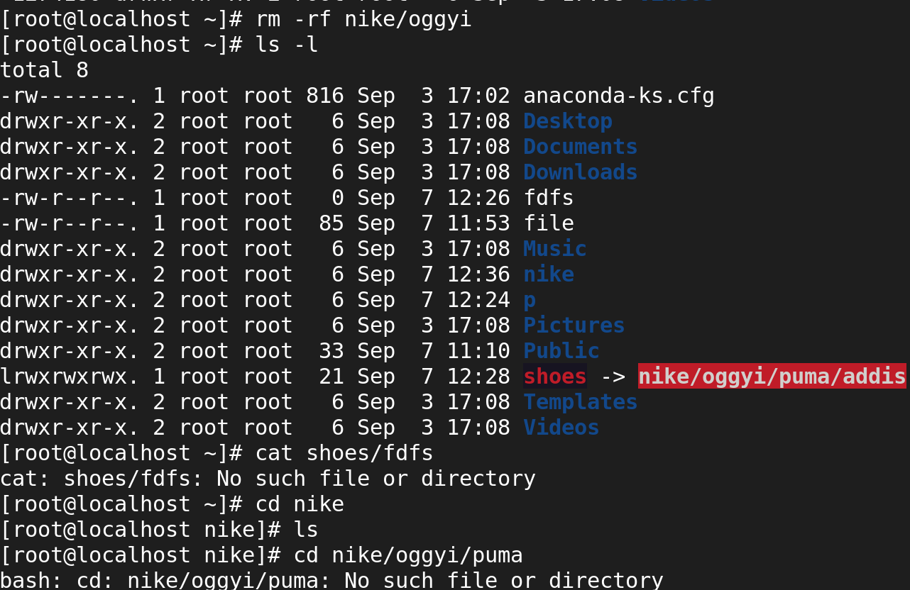

**2. Hard Links:**

➢ Hard link is a mirror copy of original file, that

means the data which is in the original file is also

linked with the linked file.

➢ Deleting the original file will not affect the linked file Because it is exact copy of original file doesn’t

impact anything.

➢ Only file can be linked here not the directory.

**Command for Hard linking a File:**

ln <source file> <destination file>

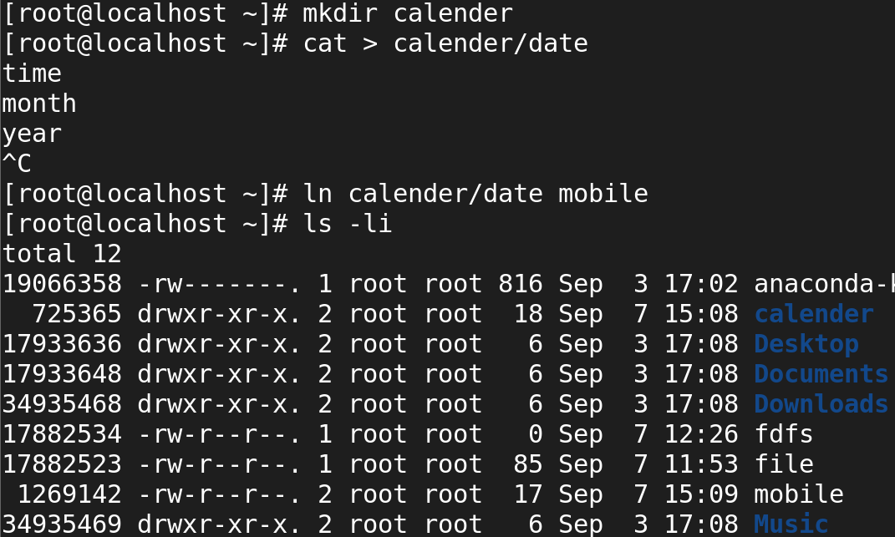

After creating the mainfile and link file iam now visiting the both io number.

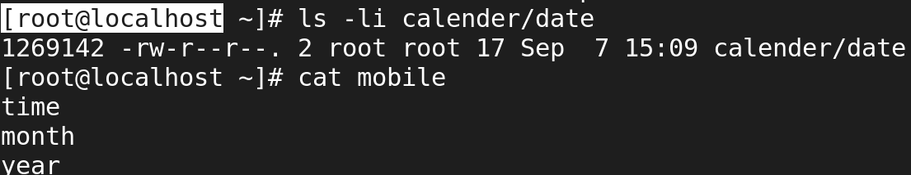

Now I removing the main file and viweing the duplicate file but data remains the same  
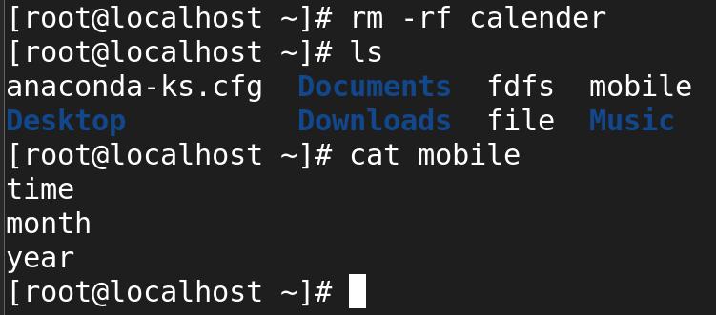

**What Is The Inode Number?**

* An inode is a data structure that is used to store information of files on your Linux system.
* The number of inodes shows the number of files and directories you have on the system
* Every inode in the Linux structure has a unique number identified with it.

**Stat command**

With the help of this command we can see the

statistics (or) details of a file

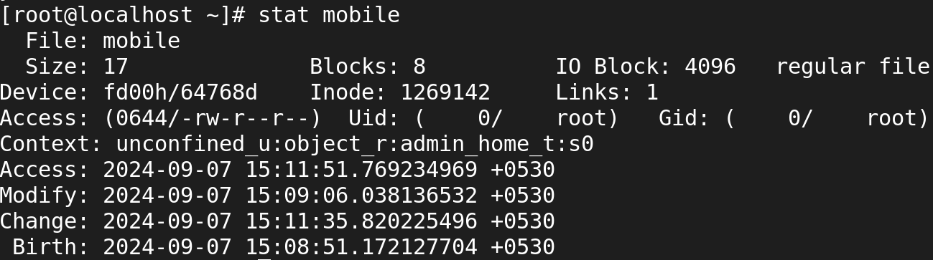

Cmd-->stat filename

**Difference B/W Soft and Hard link**

**Soft link**

1. Soft link is similar to the file shortcut in Windows.
2. Changes in both the files will reflect simultaneously
3. Soft links can be created on different file systems
4. Soft link can be created to files and directories
5. It has different inode number and file permissions compared to the original file.
6. When the original file is removed, the link will be inaccessible because it points to a non-existent file. This is called the hanging link.

**Hard link**

1. Hard link is a mirror copy of the original file.
2. It is like a soft link.
3. Hard link can only be created on the same file system.
4. Only files can be linked
5. It has the same inode number and file permissions.
6. Nothing happens when the original file is removed.

o